**Via QA home assignment**

**Introduction**​ **to Via rider app**

In the following assignment you’ll be asked to go through the “Via” rider app and answer a few questions about your experience and your understating of it.

The assignment includes questions regarding overall usability and experience, as well as questions regarding a specific feature.

The total time required for this assignment is approximately 2 hours.

**Download the app**

For starters, you’ll need to download and install “Via” application: [iOS](https://itunes.apple.com/us/app/via-ride/id657777015?mt=8), [Android](https://play.google.com/store/apps/details?id=via.rider)

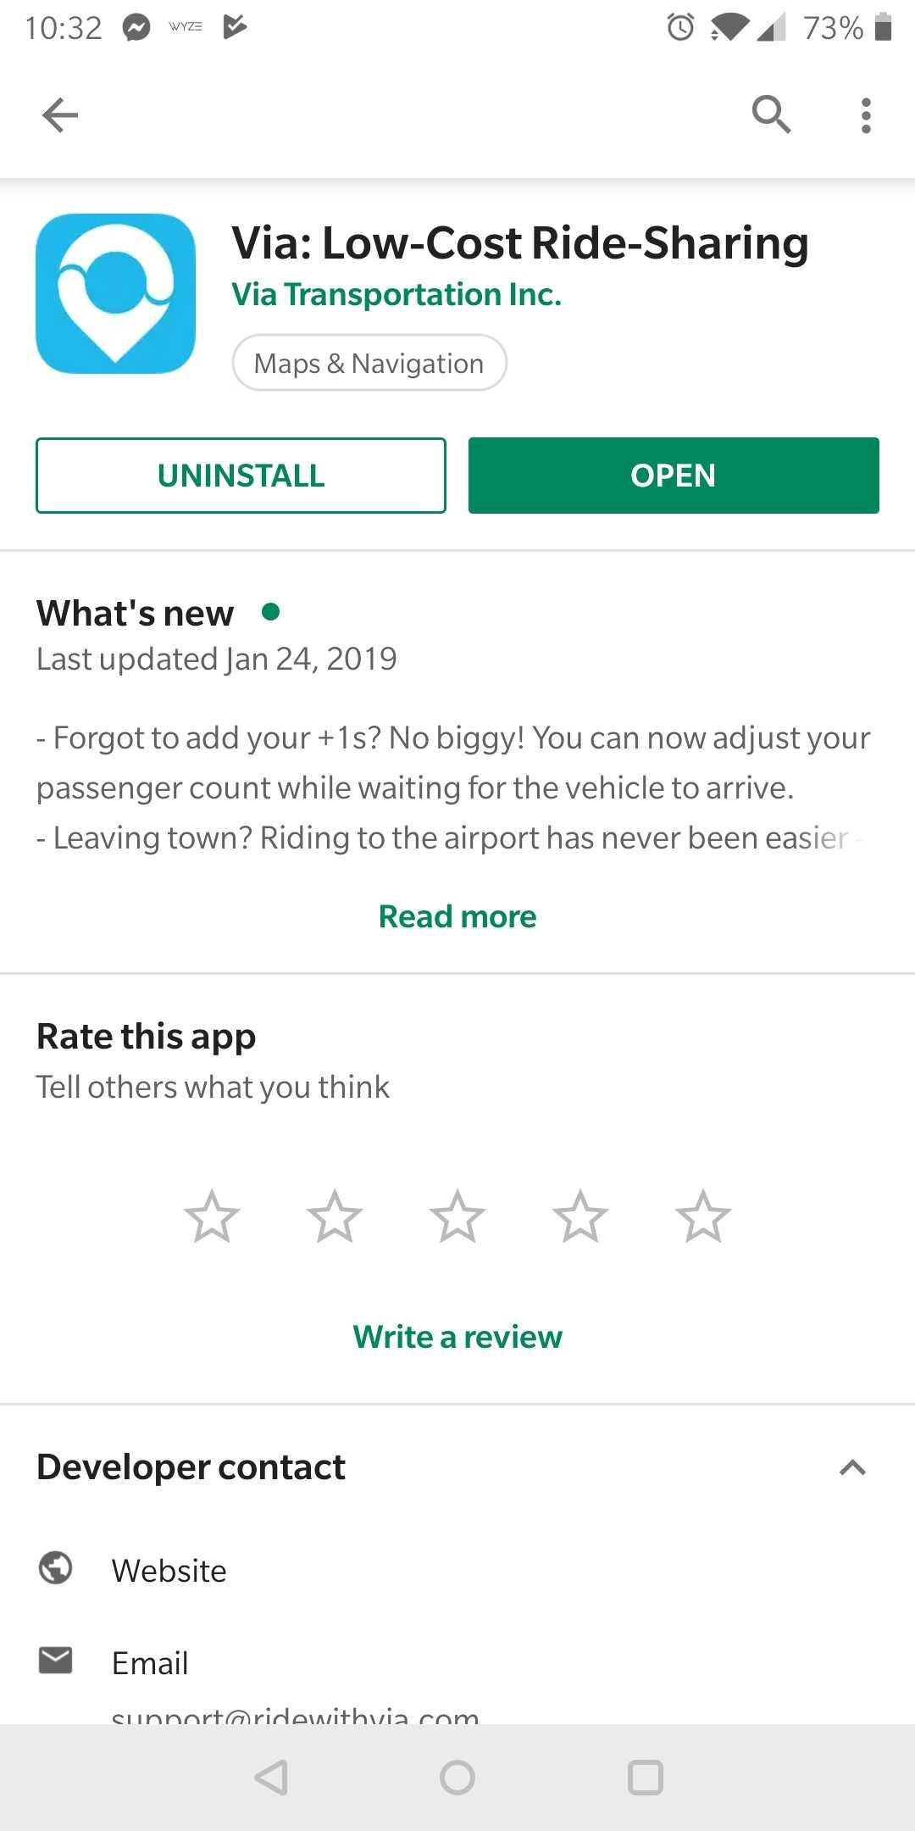

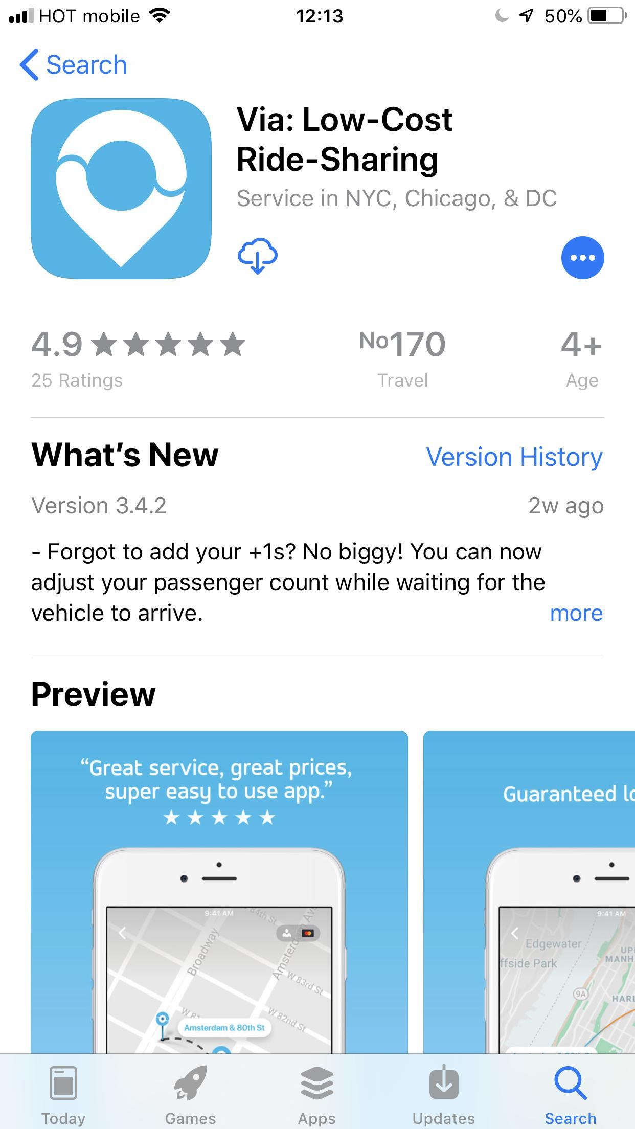

**Sign up**

After installing the app, please open it, click the “Sign me up” button, and sign up as a new user. At first, you’ll have to enter your name, phone number and email. Then, you’ll need to enter a valid credit card number - **Don’t worry**, there won’t be any use of your personal details or credit card (just make sure to follow the instructions in the section below to avoid being charged).

**Get familiar with the app menus**

Now that you’re all signed up, choose a pick-up and a drop-off in three cities: Tel Aviv, Manhattan and Chicago.

Please note that after 30 seconds, the proposal expires – in order not to be charged for the ride, **don’t** click the “Book This Ride” button:

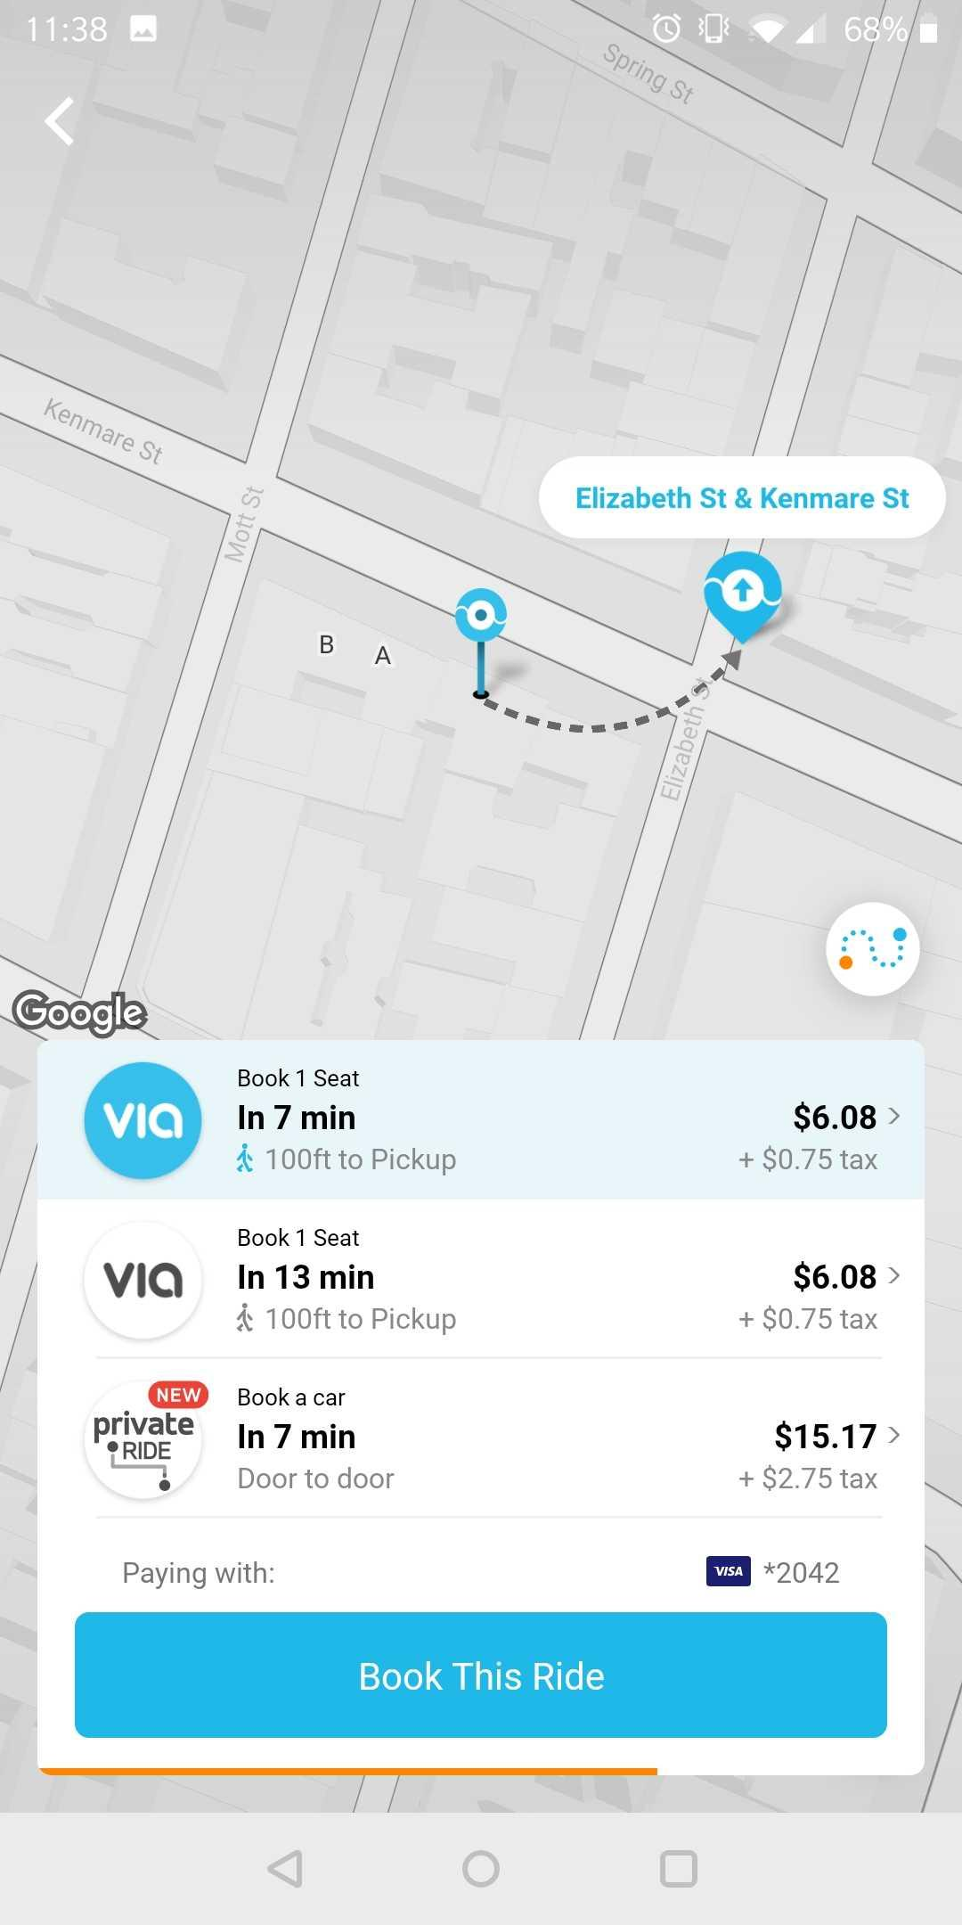

Also make sure **not to buy ride credit**, since you’ll get charged for it if you do.

Go through the app menus:

* Edit Account
* Notification center
* ViaPass
* Ride Credit
* Billing
* History
* Favorites
* Promo Code
* Free Rides
* Help Center

**Questions**

**Understanding user flows**

1. Out of the personal details you provided during the sign up process – which details are unique per user?

2. What kind of data validations are done in the sign-up process, for each sign up detail?

3. Name all the ways to pay for rides. Add a short explanation about each payment method, and explain the difference between them.

**Understanding backend flows**

In Via, we have an operational team that manages and supports riders using a management tool.

A Via operator tried to log in to the Via user management tool, but was not able to complete the login process. When the QA checked the log of this action, he/she saw the following:

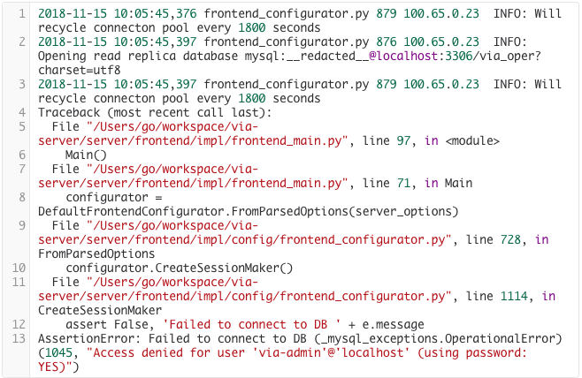

What could be the issue? Name several options.

**Testing App features**

As you saw, one of the ways to pay for rides is by using Ride Credit, which can be purchased using the Via app. If the rider has Ride Credit, it will be used automatically to pay for rides. If the Ride Credit balance is too low, Via will charge the user’s credit card.

1. Imagine that a user wants to purchase $50 in Ride Credit.

Describe, in your own words, what happens in the Via system once the user chooses the $50 and approves the purchase.

In your explanation, include the components that you think are involved in the technical flow of the Ride Credit purchase, and describe the data that is transferred between these components.

1. After the user has purchased $50 of Ride Credit, he books a ride, and the ride cost will be charged using the Ride Credit.

Describe, in your own words, what happens in the Via system once the user approves this ride booking.

In your explanation, please include the components that you think are involved in the technical flow of the ride payment using Ride Credit, and describe the data that is transferred between these components.

1. One common method for writing test scenarios is “Gherkin". Use Google to study this method, and write 5-7 sanity tests for the Ride Credit feature.  
   Focus on functionality testing and not UI/Performance tests using Gherkin syntax.

In your answer, refer both to the Ride Credit purchase process and also to the process of payment for the ride using Ride Credit.

4. What would you ask the Product Manager and/or Dev team regarding Ride Credit feature implementation and design?

5. Which 3 of the test cases that you mentioned in the previous question, in your opinion, are the most crucial for the Ride Credit feature test plan?